Lab 02 Report: Final Grade Calculator

Problem

We had to write a program which would read down a file that is separated by assignment titles such as ‘Homework’, ‘Lab assignment’, ‘labtest1’ and so forth. After reading the file, averages for each assignment or just the grade would be calculated, and will add up to a total 110% including the extra credit. The average is then divided by 100 to find a letter grade average which is rounded using Math.ceil. The grades and their averages are printed out and a raw total is printed, which is rounded to a final letter grade which is also printed.

Proposed Solution

1. Create a fileReader with the name of the file “grades.txt”.
   1. While the file has a nextLine, set a string to hold the next line. If the string equals any of the assignments mark a place and parse all the numbers adding them together and counting how many of that assignment there are.
2. Calculate the averages for each assignment and print them out.
3. Calculate rawTotal and print out.
4. Calculate final letter grade base on rawTotal and print it out after rounding using Math.ceil.

Tests and Results

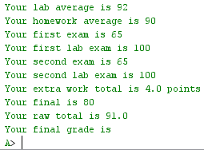 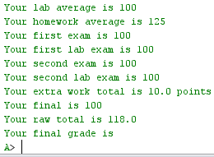

Problems Encountered

I initially wanted to store all of the data into a string array and start a new counter to count how many of each assignments once a line was not parseable into an integer but I was instructed that I was overcomplicating things and should just do it as simple as possible. I created a infinite while loop due to being told .hasNextLine() moves the cursor to the next line but it doesn’t.

Conclusions and Discussion

This lab was very helpful in learning how to read a file. There were many different solutions and methods possible to complete this lab but I am satisfied with what I did. I did however want to complete it differently as mentioned in problems encountered.

While this solution works, I feel like reading if the line equals something that the human reads from the file is not the best way to go through this file. If the tittle line such as ‘HOMEWORK’ is read, it should be tested if it can be parsed or not. If it cannot, start a new counter to mark how many of these assignments are until a line is reached that is not parseable. All of this data would be stored in an array with each index marked when a line first becomes readable.

Additional Questions

1. When you open a stream for both reading and writing files, what must you always remember to do at the end?

You must close the file scanner.

1. Define file format or protocol.

File format or protocol is how a file is saved or meant to be read. This can be .doc, .txt. or files such as tab deliminated or comma separated values (csv) files which are stored on a computer and used for different applications such as emails. Files such as csv have data separated by these commas which the computer can understand based on the file protocol used.